Load testing report of Petstore API

Purpose of the test - evaluate the performance of Petstore API under a specified workload to determine its behavior and capacity in real-world scenarios. Check the operation of the Petstore API when it reaches the pre-maximum load level and measure the response time in a short period of up to 2 minutes for 200 users.

Date and time of the test 1/31/2023 4:35 pm

Environment details Windows 10

Load test tool used JMETR

Test objectives PETSTORE API [https://petstore.swagger.io](https://petstore.swagger.io/)

Load Profile Options:

1. Number of users - 200

2. Duration - 2 min (120 sec)

3. Actions to be taken:

GET request in progress

POST request in progress

DELETE request in progress

Test Results:

Response time

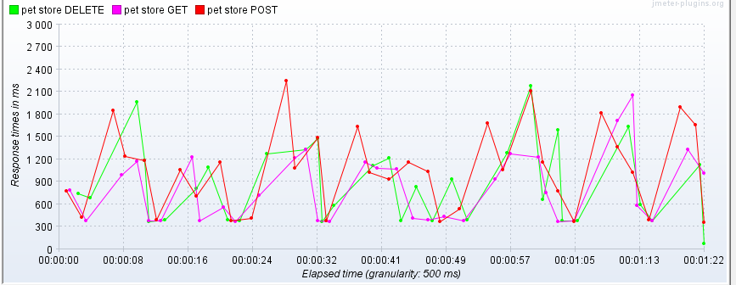

Total throughput 5.0/sec

Error rate 32.22%

Summary of the test results: Four iterations were carried out with the launch of tests. When the peak load was reached, the application server worked incorrectly, as there were saturation points (404 error).

The application doesn't work properly within the declared load range.